Objectives:
- To learn numbers in Spanish
- To learn the colours in Spanish
- To learn the days of the week in Spanish
- To recreate examples of Spanish artwork.
Did you think Mexican was a language? Guess again. There are 68 languages that are officially recognized, but there are even more spoken by smaller communities around the country.
Spanish is the most spoken language in Mexico.
This week we are learning about Mexico and the Spanish language  Helpful videos :  Spanish games with audio to learn phrases, numbers etc. https://www.digitaldialects.com/Spanish.htm  Traditional tales told in Spanish with English subtitles.  https://www.thefablecottage.com/spanish | 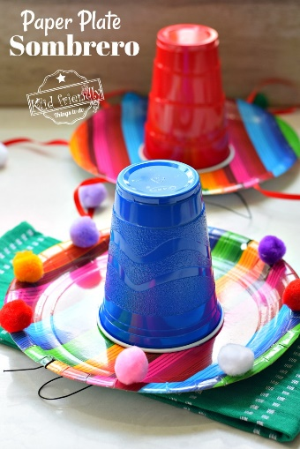
Tasks:
- Listen to the story of The Very Hungry Caterpillar. Can you write a book review? What was your favourite part of the story?
- Count how many fruits the caterpillar eats on each day. Can you say the number in Spanish?
- Look at the different colours of the fruits. Can you name them? Can you say the colours in Spanish?
- Do you know the days of the week? Can you practise saying it in Spanish?
- Watch this video and have a go at creating your own Mexican Sombrero hat https://kidfriendlythingstodo.com/make-a-paper-plate-sombrero-kid-friendly-things-to-do-com/
- Make papel picado. This is a decorative craft made out of paper cut into beautiful and elaborate designs. It is considered a Mexican folk art. https://www.youtube.com/watch?v=MEXo6p7NxSg If you don’t have tissue paper, don’t worry! Normal paper will also work.
